A Prototype Implementatoin of Light-Weight Graphics System
with Direct Rendering Manager Support

Nakhoon Baek ^{1,2,3}

¹ School of Computer Science and Engineering
Kyungpook National University
Daegu 41566, Republic of Korea
² Software Technology Research Center
Kyungpook National University
Daegu 41566, Republic of Korea
³ Dassimey.com Inc., Daegu 41566, Repbulic of Korea
oceancru@gmail.com

Abstract

In the field of computer graphics, the rendering speed is one of the most important factors. Traditionally, they use the standard graphics systems, such as OpenGL and DirectX. Since these graphics systems focused on the variety of graphics rendering features, the rendering process itself is somewhat heavy and complex. In this paper, we suggest another way of speed-up, through directly accessing the GPU hardware with the direct rendering manager (DRM). Our method shows better performance in comparison with the traditional OpenGL-based visualization methods. We present a prototype system of providing a set of simple 2D and 3D graphics primitives.

Keywords – light-weight system; graphics acceleration; direct rendering manager

I. Introduction

Since the graphics output devices are available, they developed large amounts of graphics applications. Their areas covered various fields including computer animations, computer games, user experiences, human-computer interfaces, and so on. To produce the desired two-dimensional and/or three-dimensional images on the screen, they necessarily need graphics systems and graphics API (application program interface) libraries [1,2].
Historically, we have many kinds of graphics libraries, including OpenGL [3], DirectX [4], X window systems [5], Display PostScript [6], Cairo [7], OpenInventor [8], Qt [9], and so on. Currently, three-dimensional graphics libraries are the main stream in the computer graphics and its related areas. Most 3D graphics applications use a 3D graphics library or a 3D graphics engine based on the specific 3D graphics library. At this time, OpenGL and DirectX are among the most widely used 3D graphics libraries.
In some graphics applications, the display speed may be one of the most critical factors. Since the data set is too large for most 3D graphics libraries, a little bit of speedup in the rendering process can result in the much speed-ups.
Though some graphics engines and full-size tools are available, they focus on the efficient user interfaces rather than the execution speed. Therefore, currently, those graphics libraries of OpenGL and DirectX are regarded as the most efficient way of high speed rendering for the large scale precise rendering data.
In contrast, the graphics application programmers focused on the both side of speed and simplicity of the visualization process. To represent more realistic scenes, they need precise and accurate numerical data on the graphics models. One of the most important features is actually how to efficiently and rapidly display those data on the screen. In contrast, they also pursue the easy and intuitive way of handling those big size data.
In this paper, we present a low-level programming way of accelerating the graphics rendering especially for large-scale data visualization. We focused on the low-level data packets between the main board and the graphics cards. After initialization of the rendering pipeline, we transfer the rendering data through these low-level data packets. We finally achieved remarkable speed-ups with these new low-level implementation of rendering processes.
More technically, our method is based on the Direct Rendering Manager (DRM) [10,11]. For some specific cases, the application programs require only the fixed-function rendering schemes, and then, we can implement the specific functionality into the DRM-based low-level graphics programs, instead of the traditional OpenGL or DirectX. In this paper, we represent the design and the prototype implementation of the DRM-based accelerated rendering system.

II. Design of the Rendering System

The start point of our idea is that modern windowing systems have many overheads to handle the windowing system itself. Every graphics window should handle the user interactions and window-to-window events, and all other user interface system-dependent issues. In contrast, some computer graphics architectures adopt direct managing systems, which accesses the framebuffer directly, as shown in Figure 1.

Fig. 1. Windowing systems and direct management of framebuffers.

In the case of Linux and its derived systems, the direct rendering manager (DRM) module has been used to access the framebuffers directly. In modern computer graphics architecture, the graphics processing unit (GPU) is essential to the framebuffer management and various graphics processing. Thus, the modern DRM module now also manages the GPU in addition to the traditional framebuffer.
The Direct Rendering Manager (DRM) is actually a module of the Linux kernel. Its major role is to provide an Application Programmer’s Interface (API) to the Graphics Processing Unit (GPU). The upper layers, including OpenGL and other application-level graphics libraries, use this DRM module as the standard way of transfer the data to the GPU. A programmer can send the rendering commands and the target data to the GPU, through calling DRM functions, as shown in Figure 2.

Fig. 2. The DRM module in the Linux Kernel.

The DRM module provides additional functionalities including framebuffer managing, mode setting, memory sharing objects handling, memory synchronization, and others. Some of these expansions had carried out their own specific names, such as Graphics Execution Manager (GEM) [12] or Kernel Mode Setting (KMS) [13]. Those parts are actually the sub-modules of the whole DRM module. The detailed description of those modules are followed in the subsections.

2.1 Graphics Execution Manager

The Graphics Execution Manager (GEM) is the open-source Linux graphics driver approach for handling in-kernel graphics memory management. GEM is originally designed to manage graphics memory, control access to the graphics device execution context and handle the essential environment unique to modern graphics hardware [12]. GEM allows multiple applications to share graphics device resources without the need to constantly reload the entire graphics card. Data may be shared between multiple applications with gem ensuring that the correct memory synchronization occurs.
Graphics data can consume arbitrary amounts of memory, with 3D applications constructing ever larger sets of textures and vertices. Historically, the traditional graphics application programs send the rendering data from the main memory to the graphics memory, for each context switching. For more speed-ups, ensuring that graphics data remains persistent across context switches allows applications significant new functionality while also improving performance for existing API’s.
Modern Linux desktops include significant 3D rendering as a fundamental component of the desktop image construction process. 2D and 3D applications paint their content to off-screen storage and the central 'compositing manager' constructs the final screen image from those window contents. GEM provides simple mechanisms to manage graphics data and control execution flow within the Linux operating system.

2.2 Kernel Mode Setting

The graphics card should set a specific mode of the graphics display. So, the screen resolution, number of bits for the color and depth representation, refresh rate, and others are set by this mode. This operation usually requires low-level access to the graphics hardware. A mode-setting operation must be performed prior to start using the framebuffer, and also when the mode is required to change by an application or the user.
Kernel Mode Setting (KMS) is a method for setting display resolution and depth in the kernel space rather than user space [13]. The Linux kernel's implementation of KMS enables native resolution in the framebuffer and allows for instant console (tty) switching. KMS also enables newer technologies (such as DRI2) which will help reduce artifacts and increase 3D performance, even kernel space power-saving.

III. Experimental Implementations

In the case of Linux kernels, the direct rendering manager (DRM) module is used to access the graphics processing unit (GPU). The upper layers, including OpenGL and other application-level graphics libraries, use this DRM module as the standard way of transfer the data to the GPU.
Typical graphics programs send the data as a mixture of the target data and the rendering commands for those data. In the case of large-scale data visualization, the portion of the target data is dramatically high, with very small amount of the rendering commands. Currently graphics libraries, however, use the normal way to transfer the data and commands, as a set of mixtures.
In our implementation, we set up the rendering commands with the normal OpenGL commands, to pursue the easy and intuitive user interfaces for the graphics programmers. Then, we by-pass the high-level libraries including OpenGL and similar ones. Instead, we send the DRM packets directly to the GPU. In this way, we can remove the duplicated rendering commands in the normal rendering pipelines of the OpenGL and other high-level graphics libraries.
As a prototype implementation, we used a set of point clouds from LiDAR devices, which typically consist of more than 3 million color points, as shown in Figure 3. With the original OpenGL programs, those 3 million data points are rendered with a set of rendering commands and data, due to the normal OpenGL limitations. However, our implementation uses the low-level DRM packets to send the whole data to the GPU. This technique shows reasonable speed-ups.

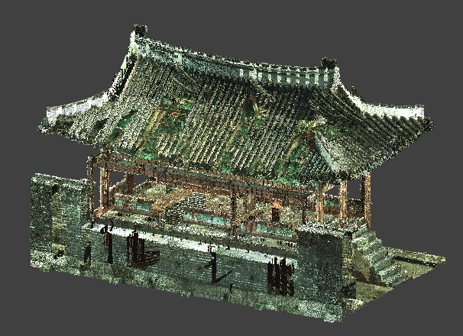
Fig. 3. An example of large-scale data visualization.

Fig. 4. An example of 2D graphics output.

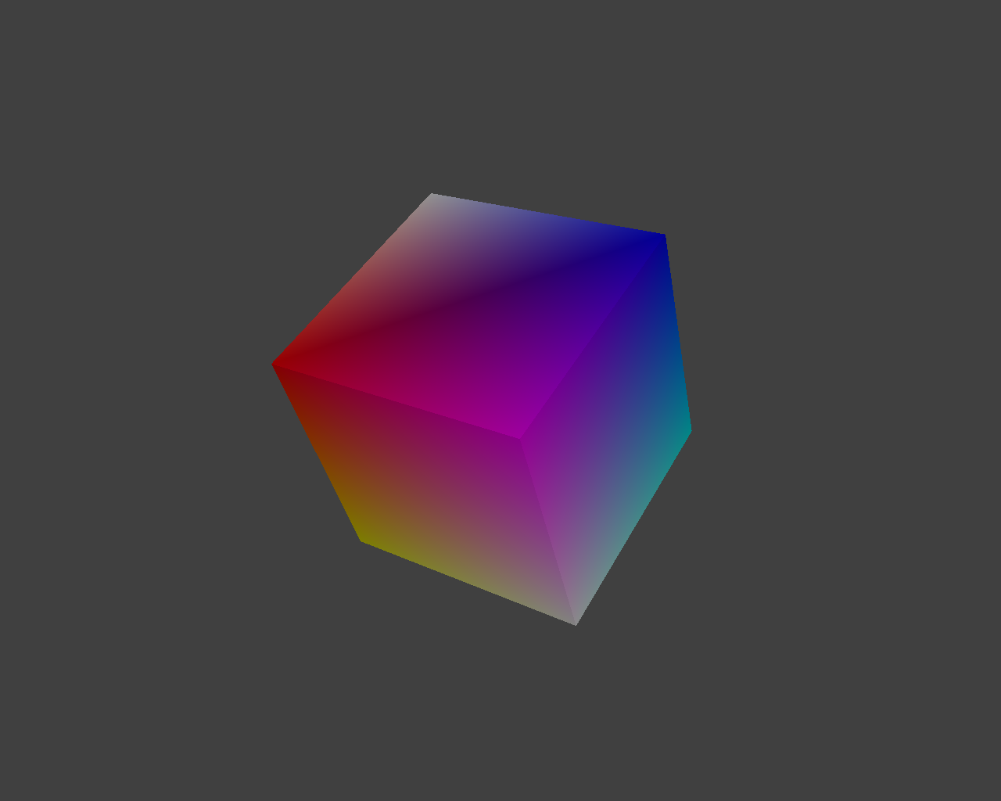

Fig. 5. An example 3D graphics output.

From an existing OpenGL application program, we can extract the shader programs for a fixed rendering pipeline. Then, we use the low-level DRM functions to build-up a minimum system to execute the extracted shader programs. In this case, our application level interfaces are directly connected to the Linux kernel level support to the GPU executions. Based on this simple and intuitive idea, we have implemented the first prototype system, as shown in Figures 4 and 5. This system can display 3D graphics primitives without any commercial graphics library, such as OpenGL and DirectX.

IV. Conclusion

In these days, typical graphics tools and application programming interface libraries are designed to support easy-to-use user interfaces and function calls. In the case of large-scale data visualization, the rendering speed is more important. This paper shows a new way of efficiently rendering large-scale rendering data, through the DRM packets. It shows reasonable speed-ups.

Acknowledgement

This research was supported by Basic Science Research Program through the National Research Foundation of Korea (NRF) funded by the Ministry of Education, Science and Technology (Grant 2016R1D1A3B03935488).
This study was also supported by the BK21 Plus project (SW Human Resource Development Program for Supporting Smart Life) funded by the Ministry of Education, School of Computer Science and Engineering, Kyungpook National University, Korea (21A20131600005).

References

[1] Hughes J.F., et.al.: Computer Graphics: Principles and Practices, 3rd Ed., (2013).
[2] Capin, T., Pulli, K., Akenine-Moller, T, 2008, "The State of the Art in Mobile Graphics Research," IEEE Computer Graphics and Applications, 28(4):74-84.
[3] Segal, M., Akeley, K.: The OpenGL Graphics System: A Specification, Version 4.5 (Core Profile). Khronos Group, (2016).
[4] Luna F.: Introduction to 3D Game Programming with DirectX 12, Mercury Learning & Information (2016).
[5] Young, D.: The X Window System: Programming and Applications with Xt, OSF/Motif (2nd Edition), Prentice Hall, (1994).
[6] Adobe Systems: Programming the Display Postscript System With X (APL), Addison-Wesley, (1993)
[7] http://www.cairographics.org/
[8] Wernecke J.: The Inventor Mentor: Programming Object-Oriented 3D Graphics with Open Inventor, Addison-Wesley, (1994).
[9] Lazar, G.: Mastering Qt 5, Packt Publishing, (2017).
[10] Faith, Rickard E.: "The Direct Rendering Manager: Kernel Support for the Direct Rendering Infrastructure". http://dri.sourceforge.net/doc/drm_low_level.html. (2016)
[11] Fonseca, J.: Direct Rendering Infrastructure: Architecture. (2005).
[12] K. Packard and E. Anholt: The Graphics Execution Manager: Part of the Direct Rendering Manager, on-line article, (2008).
[13] https://wiki.archlinux.org/index.php/kernel_mode_setting

